**SERVICENOW SYSTEM ADMINISTRATION TRAINING - 1**

Topics to be covered are:

* Introduction of the course
* Platform Overview and Architecture
* User Interface and Branding
* List and filters
* Forms
* Task Management
* Notifications
* Knowledge Management
* Service Catalog
* Tables and Fields
* Access Control List
* Data import
* CMDB
* Integration
* Events
* Update Sets
* Platform Sets
* Scripting in ServiceNow
* Custom Application Development
* Recap

**Introduction of the course:**

* Knowledge of ServiceNow Platform Features
* Understanding the Architecture
* ServiceNow Fundamentals
* To perform ServiceNow Admin activities.

**Platform Overview and Architecture:**

* ServiceNow provides an Application Platform as a Service (APaaS).
* It is a cloud-based computing model which provides the infrastructure needed to develop, run, and manage applications.
* Organizations can utilize ServiceNow to automate manual repeatable processes and standardize their service delivery.
* Before ServiceNow was a ticketing tool but now, it is an automation platform in which you can automate different business processes.

**ServiceNow Architecture:**

* Application Platform as a Service
* Single data model
* Multi-instance
* High availability architecture data centres
* Frequent backups

**Multi-tenant architecture:**

All the three companies have shared the application infra by the service provider.

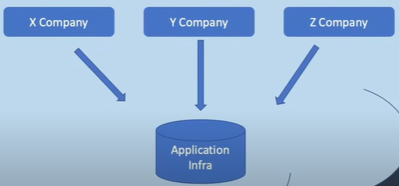

**Multi-instance architecture:**

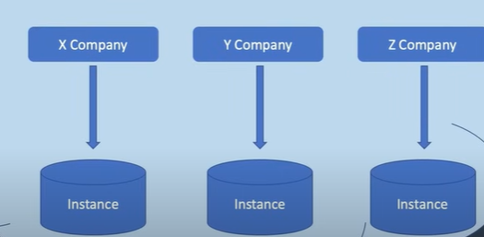

It is provided by ServiceNow in which every organization has its instance whose maintenance will be different from others.

**Back-up:**

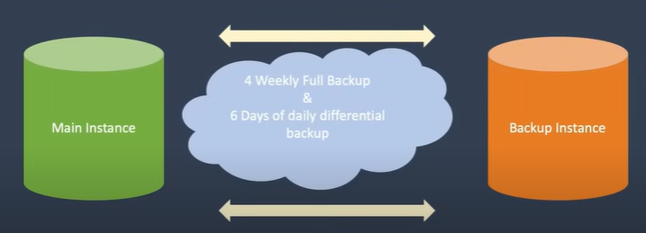

We need backups because if you break something in your instance, ServiceNow can restore everything to normal with the help of a backup. This backup is also used in cloning activity as lower instances are copied from production instances.

**Security:**

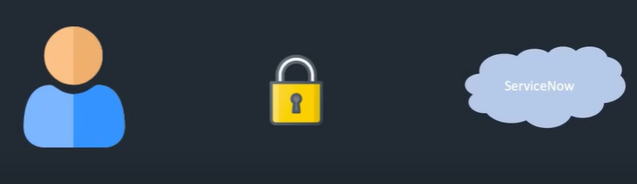

**Platform Interface:**

ServiceNow provides 3 ways to interact with the platform

1. User interface aka native UI:

Native UI is the main way to interact with the applications and information in the ServiceNow instance. ServiceNow platform user interface features include real-time form updates user presents enhanced activity streams and an application navigator designed with tabs for favourites and history.

1. ServiceNow mobile interface:

This type of interface provides 3 different types of mobile applications:

1. ServiceNow Agent
2. Now mobile
3. ServiceNow Onboarding

ServiceNow administrators can configure these applications as per the business requirement. These applications help employees and users working in service now to work more efficiently and productively on the go.

1. Service Portal interface

The service portal provides a user-friendly self-service experience. it is an advanced Ui of the ServiceNow platform that provides access to specific features by using different widgets that can be customized and developed by ServiceNow developers. users can search for knowledge articles request for any service and much more.

These interfaces access the same system of record and common data model of the ServiceNow platform. For example, If you have one ServiceNow instance, all these interfaces can now access the same instance with the same data.

**Components:**

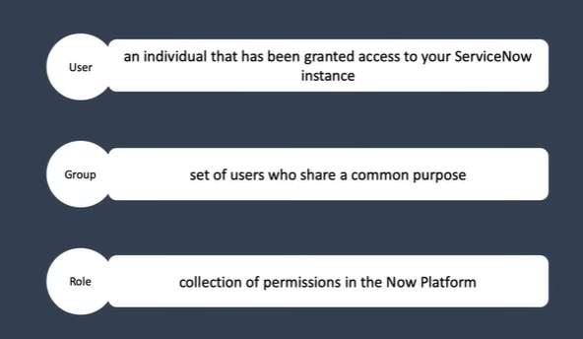

**Roles assigned to a group:**

**Base System Roles:**

ServiceNow comes with baseline roles and features for out-of-the-box applications.

For example, the admin role will provide you access to the whole platform, and this role is added to all the administrators and developers of the ServiceNow instance then we have the approver underscore user which is also one of the types of role that provides access to approve the tasks itil role which provides read and write access to itsm applications like incident change and problem catalog underscore admin which allows access to manage service catalog and many more roles users can still login into service now even if they don't have any role assigned to them and access some of the applications and elements like home page raising of incident and request accessing the service catalog these users are also called as self-service users.

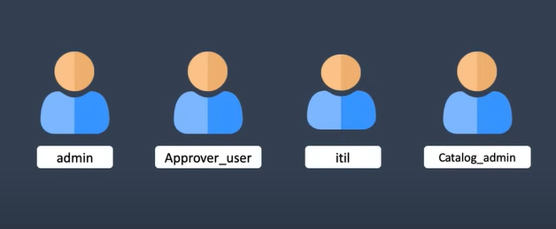

ServiceNow has one of the major features that is “impersonate”.

It means you can get any user's view if you have proper rights as I have admin access.

Let's see how to impersonate a user who does not have any role.

Access the instance -> user administration -> user -> New

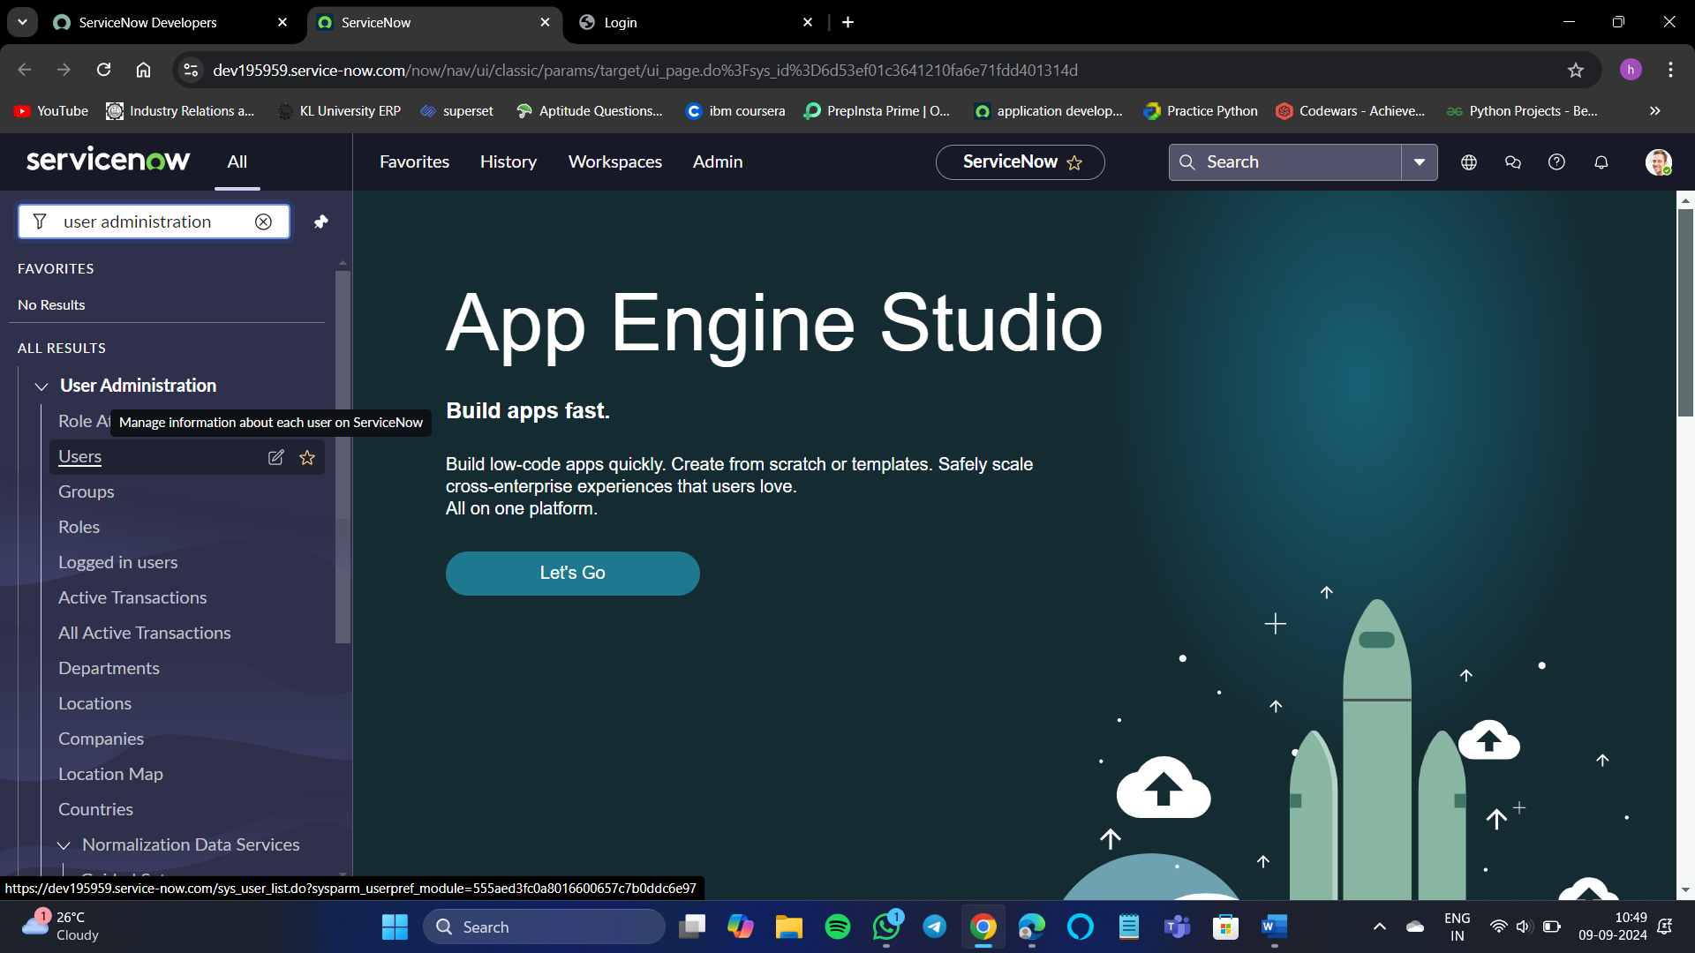

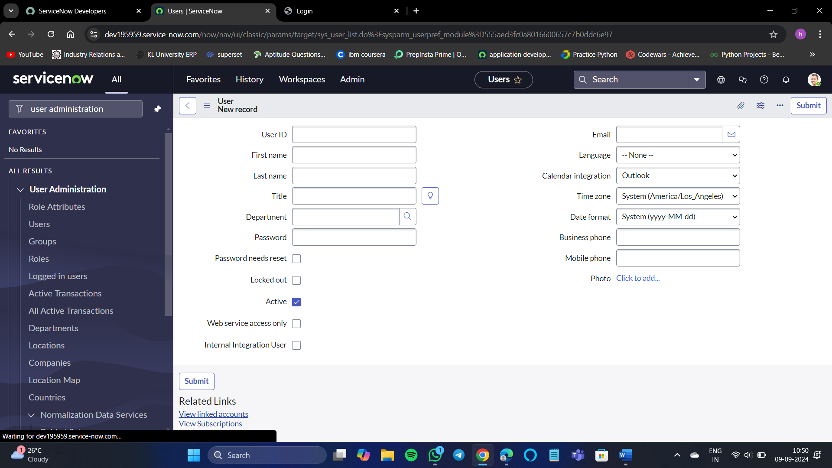

After naming the user info we need to set a password for the record.

First, we need to save the user info then it will show us about setting the password for the record or not in the banner.

Select Set Password and generate a random password, then save changes.

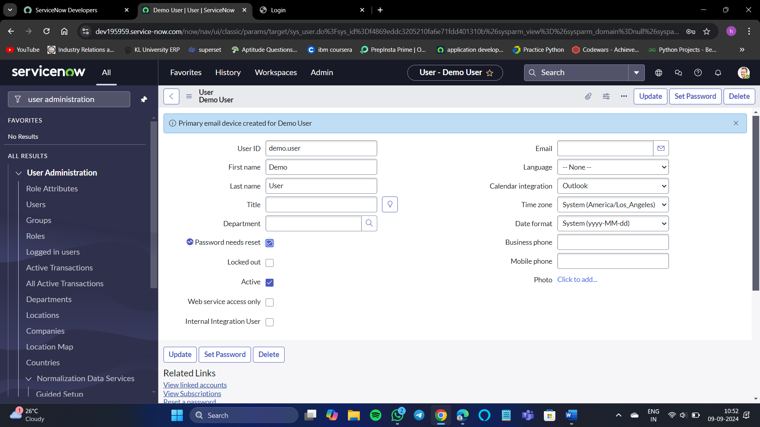

**User interface:**

ServiceNow now has 2 UI versions:

1. UI 15 – Old Version
2. UI16 - New Version

We can switch to any of these instances according to our choice.

System settings -> General -> Switch to UI15

**UI Elements:**

ServiceNow’s main screen is divided into 4 main UI elements:

1. Banner Frame

* Company logo and Name of the instance
* User menu(Profile, Impersonate user, Elevate roles, Logout)
* Global Search
* Chat, Help, Settings

1. Application navigator

* All application tab
* Favorites tab
* History tab

1. Content Frame
2. The 4th element is not visible in UI16 but visible in UI15 version of ServiceNow platform. It is called Edge.

**Branding overview:**

Branding means configuring your instance to identify as per your company.

Converting the Now platform as per your company portal, and customization of the portal according to our wish.

There are 2 ways to branding the portal:

1. By Basic Configuration U16
2. By ITSM Guided Setup

Method – 1:

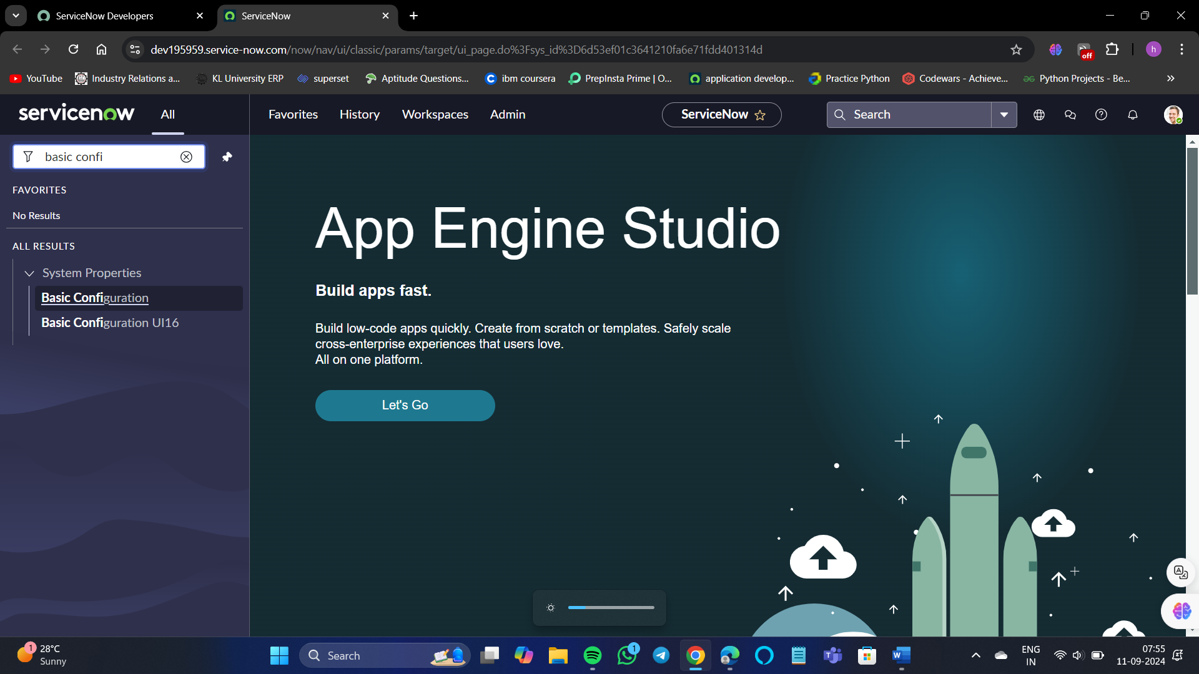

Search basic configuration and go for basic configuration UI16 option.

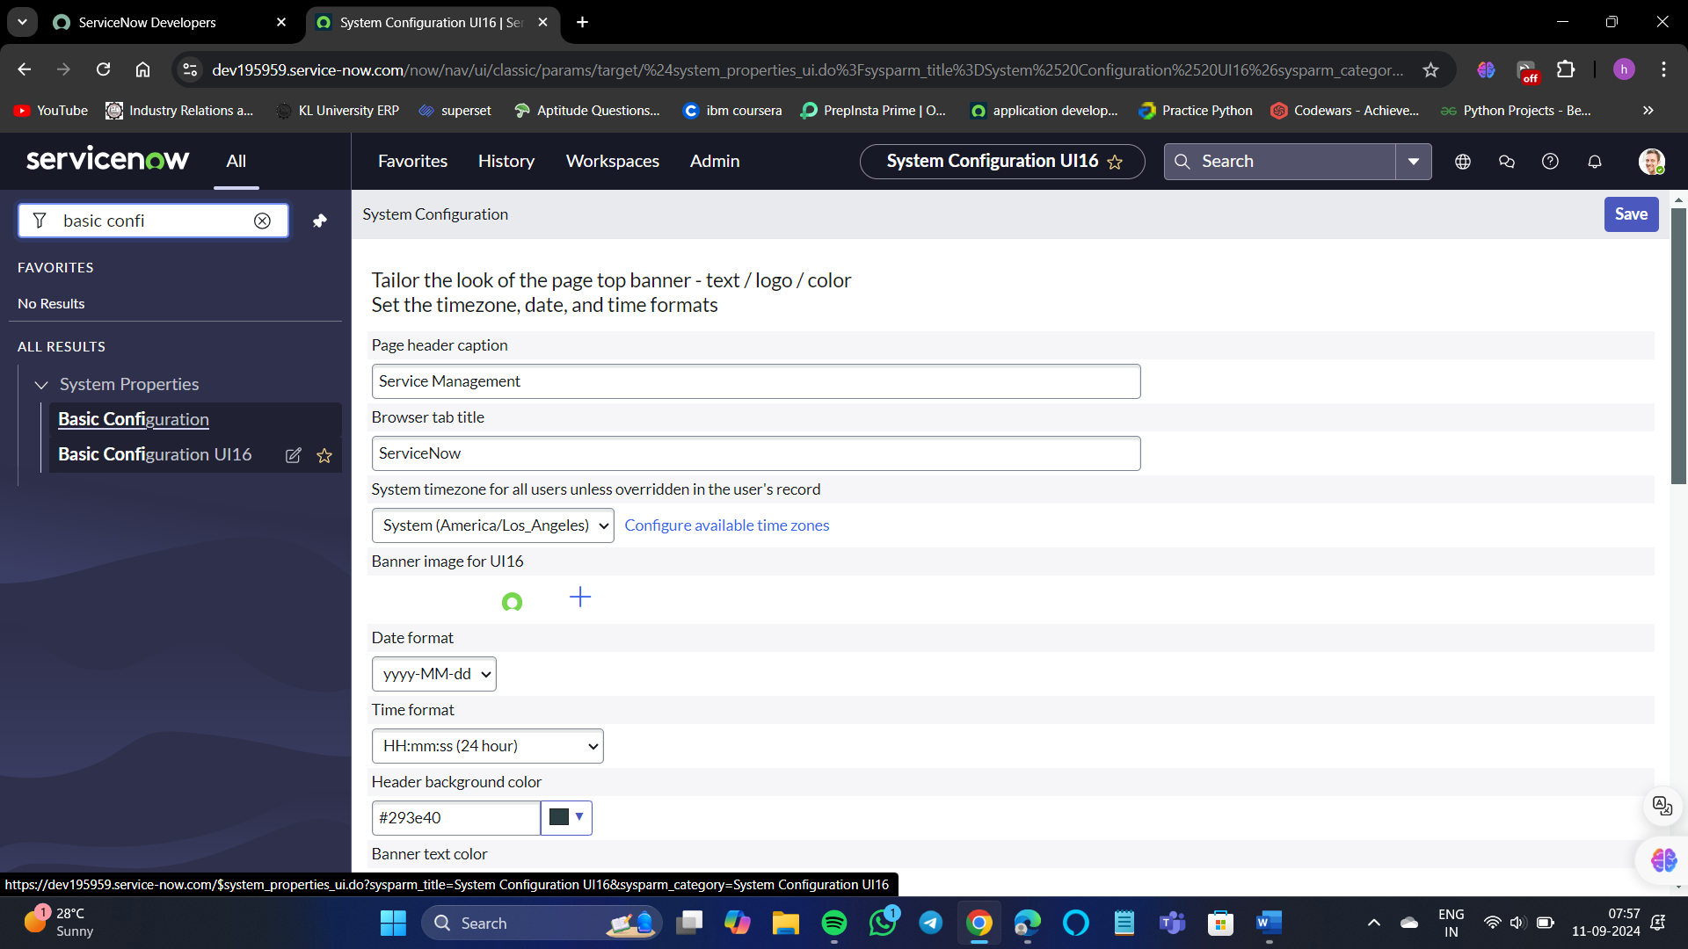

Here we can see a wide range of options to customize the portal.

For example, I want to change the company to this logo



Click on the + symbol to add the image.

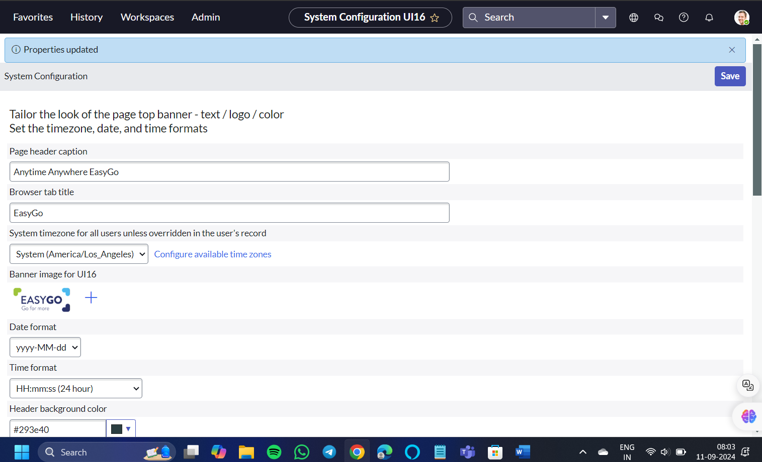

After saving the changes, you need to refresh the site for you to see the changes



This is one method of customizing the portal

Method – 2:

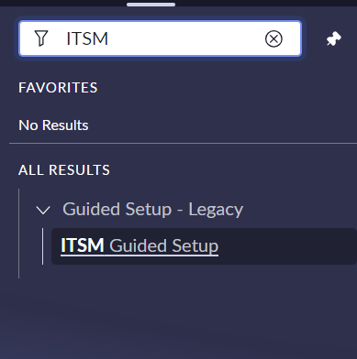

Go to ITSM guided setup.

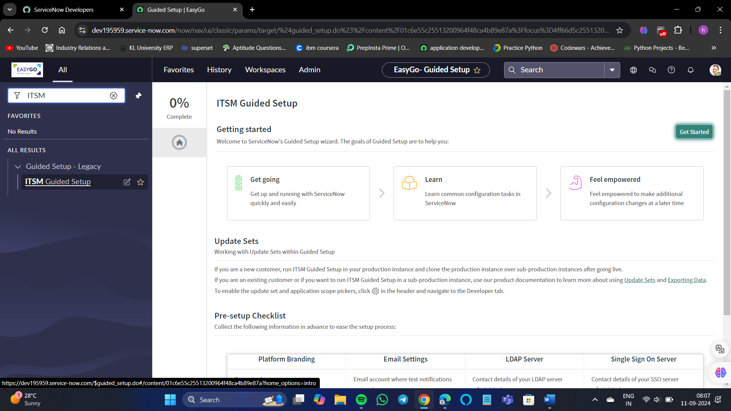

We can see here Platform Branding. Click on “Get started”.

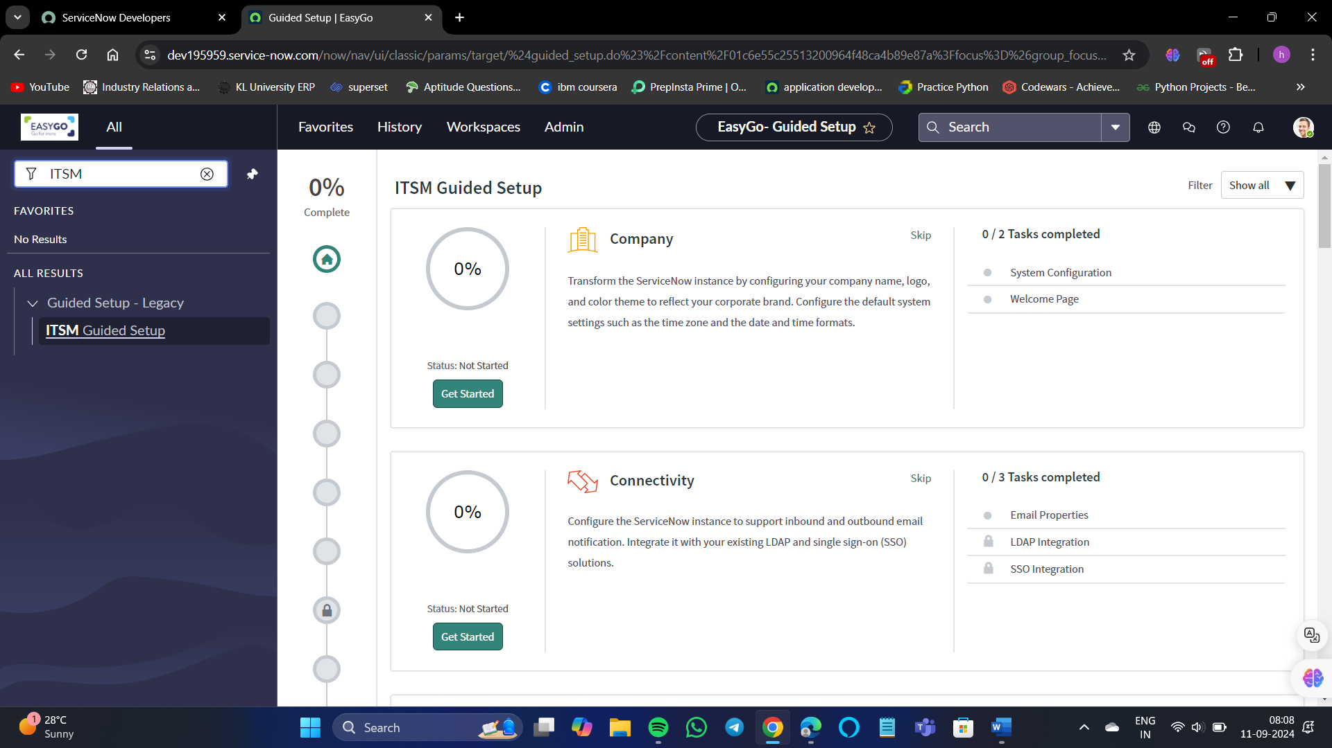

The first option as we can see is the “The Company” option.

And there are 0/2 tasks completed, for us to see the change in the portal we need to complete those 2 tasks.

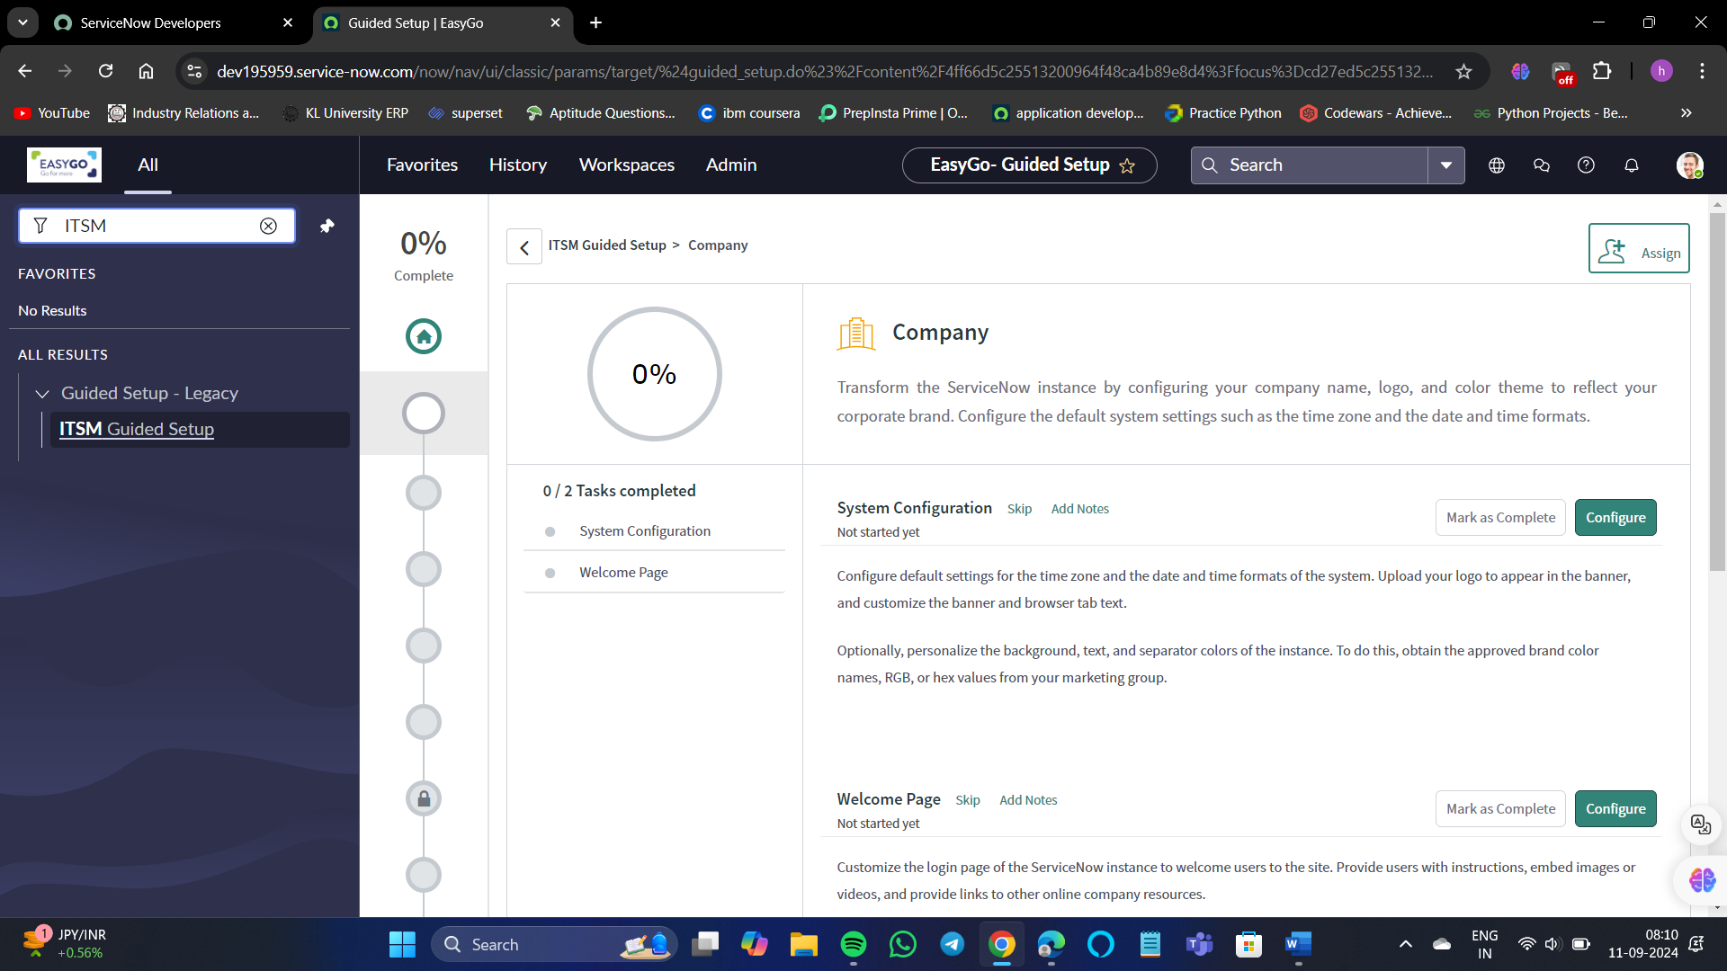

The 2 tasks are visible to us. To complete the task select/click on configure option.

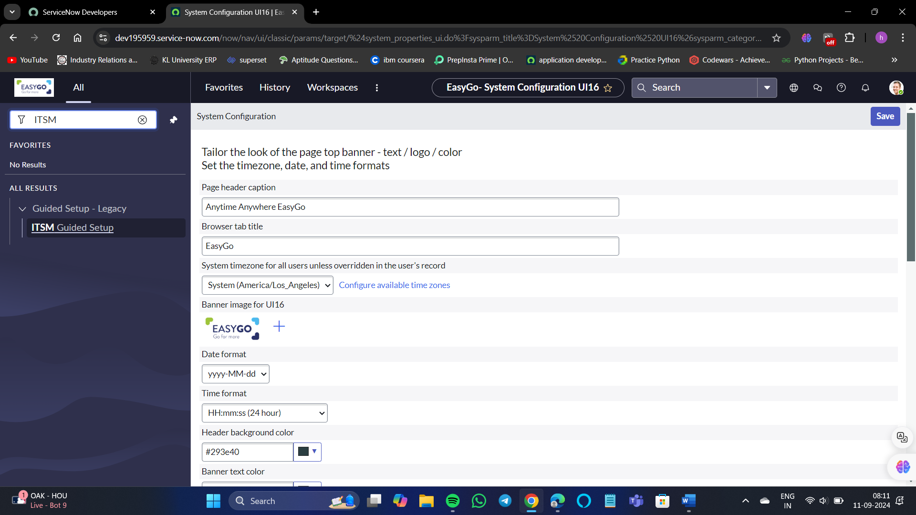

You can see the same page as before which was of basic configuration UI16.

Save changes and then refresh the page to make sure that the changes are visible to us.

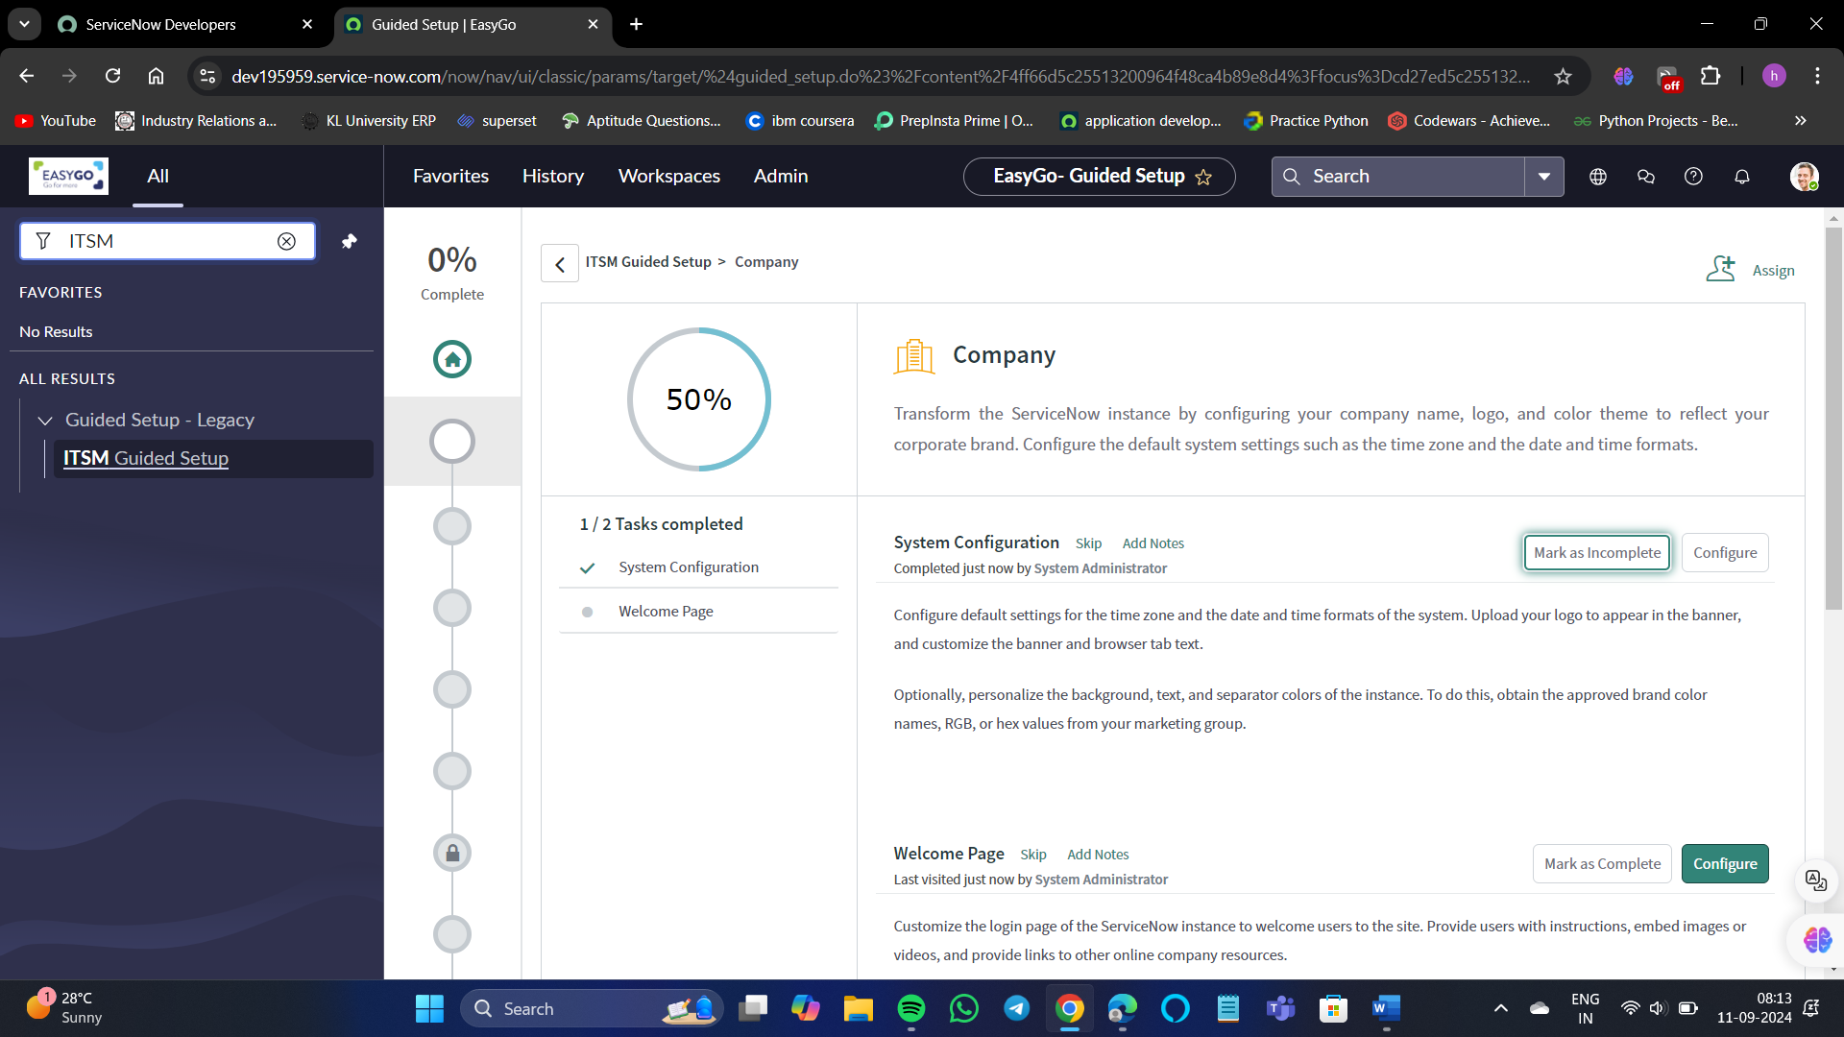

After completing the task select “Mark an complete”.

Now coming to the 2nd task.

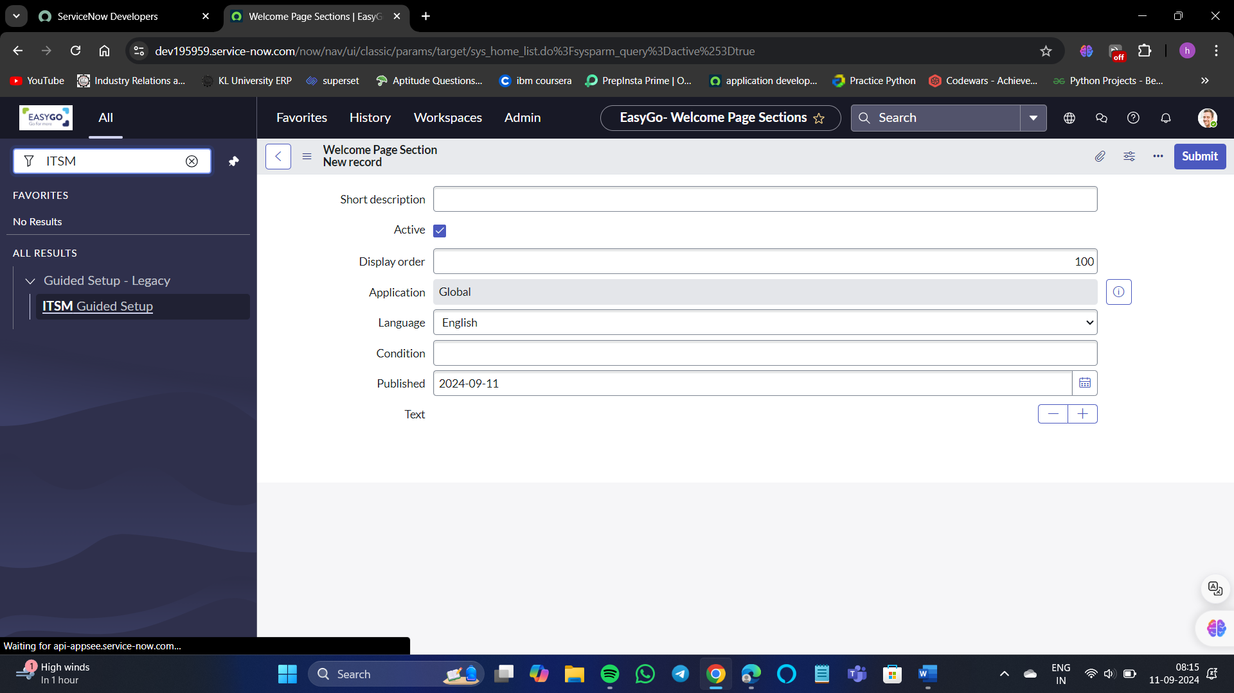

Creating a new record.

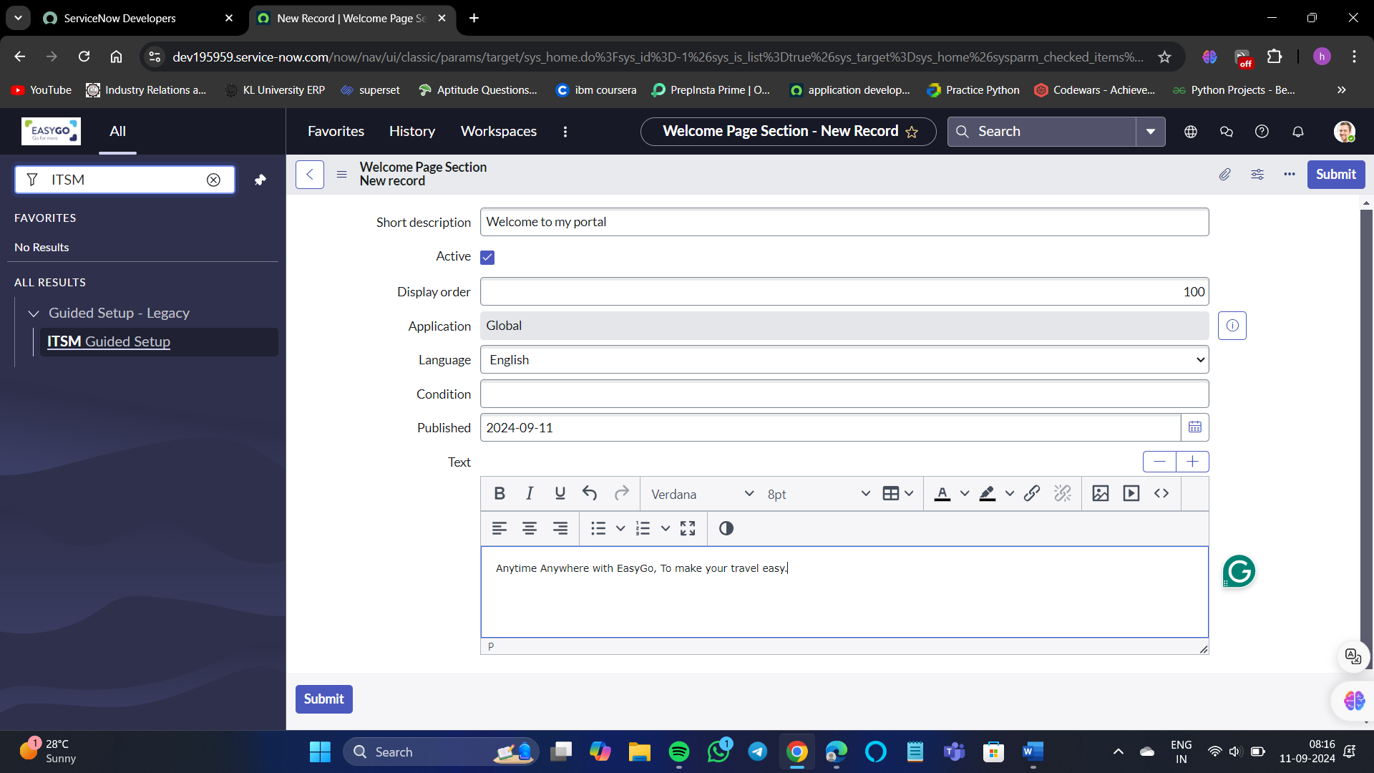

Submit.

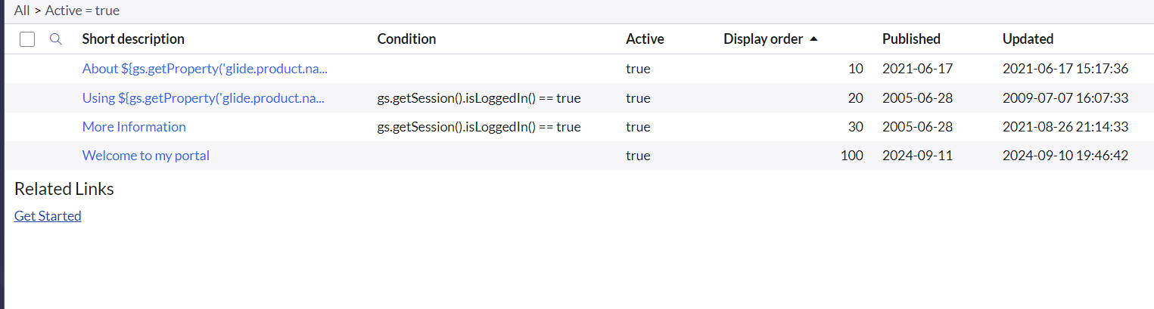

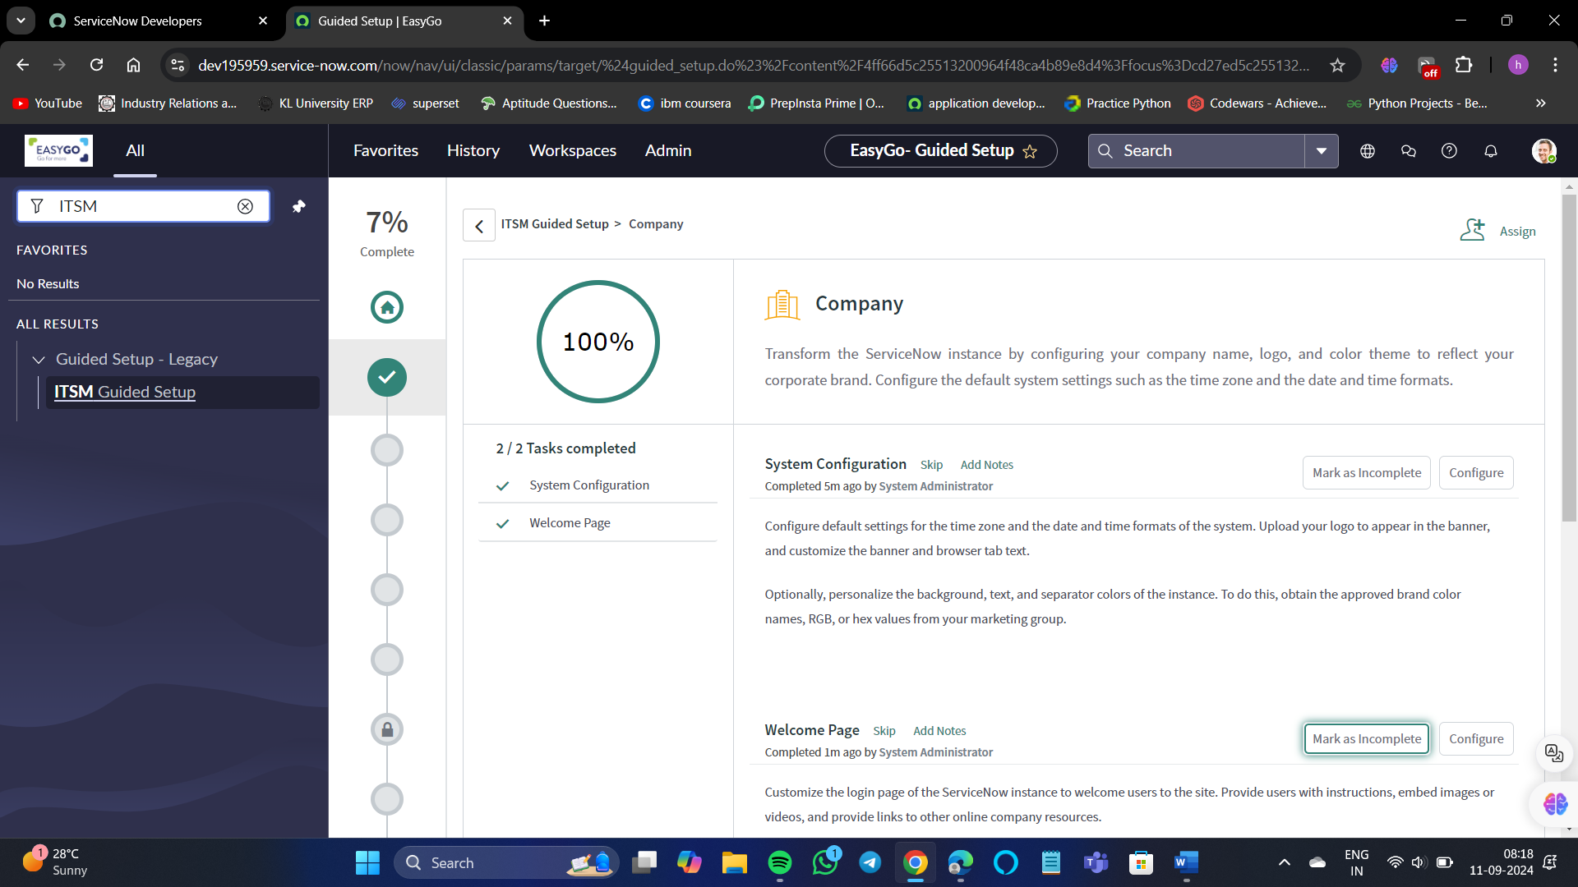

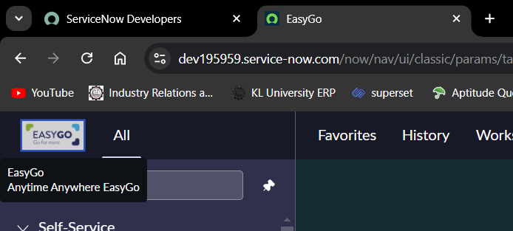



This is how you can customize the portal.

**List and Filters:**

**List:**

* The list displays the racket from a data table such as the incident problem or user table.
* A list is a content page that displays records from a table, organized in rows and columns.
* Each row represents a record, and each column represents a field in that record.
* Lists can be filtered and categorized to display specific sets of data, such as "All tasks," "Open tasks," or "My tasks," allowing users to manage and access relevant information efficiently.

**List elements:** There are many different elements of list.

* Main list: shows the list of records in a table like incident table records in a list.
* Title bar
* Filters: which is used to put condition and filter the data displayed in the list of table records.
* Breadcrumbs: which is created when you add different filter conditions and shows what conditions are selected.
* Column and Field: which is the field of the table where data is stored for a table racket as you can see we have a number field selected it's a column and it's a field as well where the number of the record is being stored.
* List Title Menu:
* View
* Filters
* Group By
* Refresh List
* Create Favorite
* List Context Menu: Left-click on the title bar to display this list, it has much more options than the list title menu.

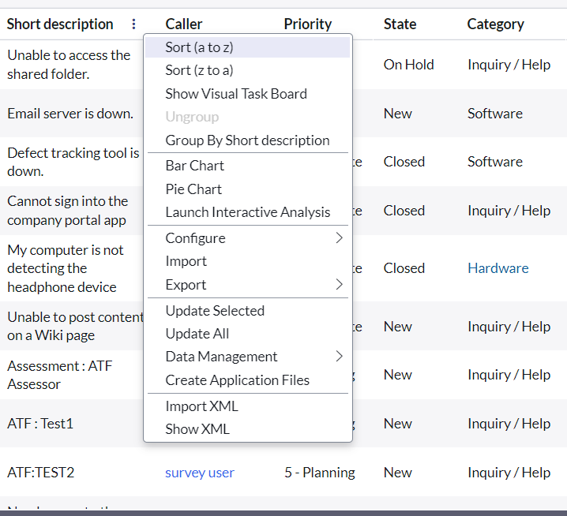

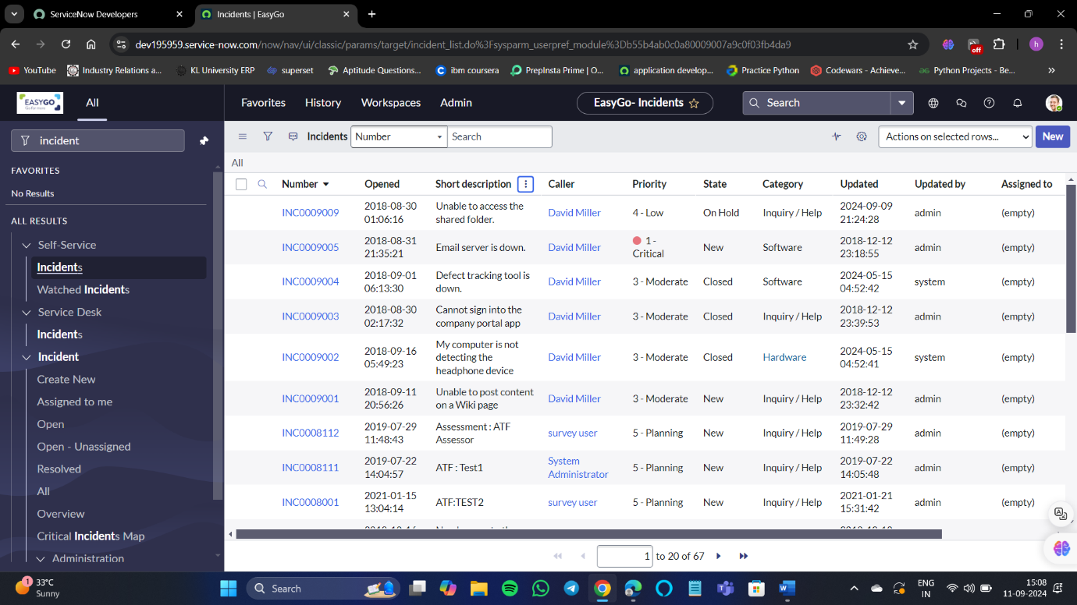Now let us have a look on the incident table.

There is a filter option on the title bar. Using the title bar, we can filter the data according to our wishes. For example,

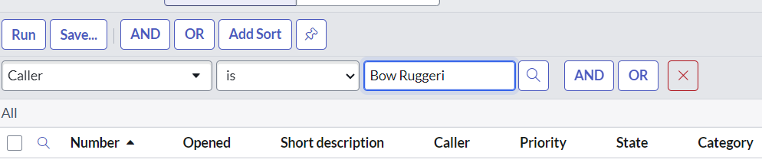

I want the details of a caller named Bow Ruggeri to be displayed. Click on the run for the details to be displayed.

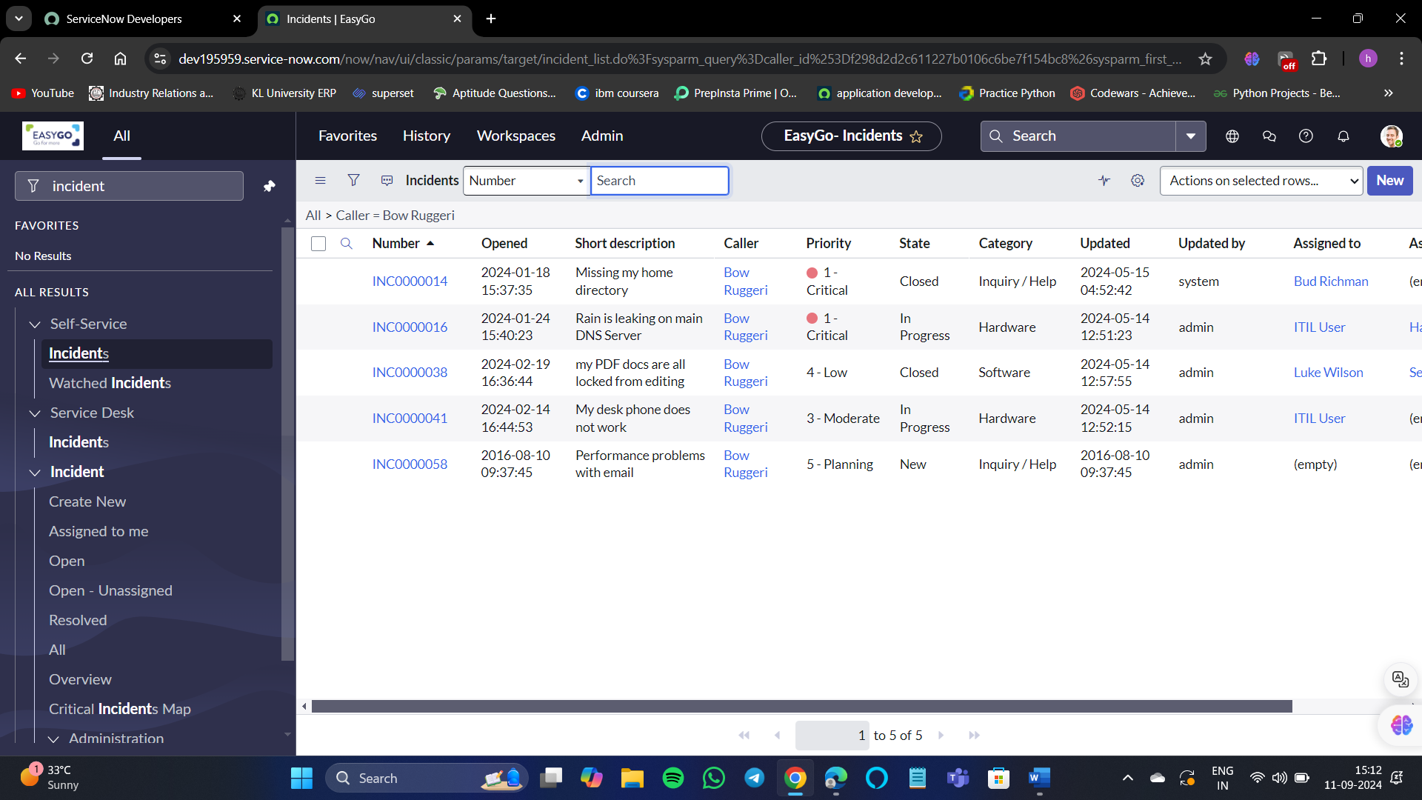

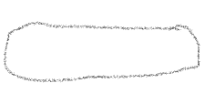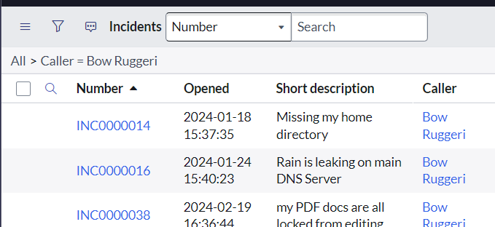

That condition is known as breadcrumb.

So, now according to our wish, we can display the data of our need by selecting multiple options.

Let’s, explore more options such as right-clicking on the title bar, then we can see a list of options one of which is View.

You can create different views based on your use case.

The view is important because the data you are seeing in the fields might happen that as per the view you might want to change.

The group by option in ServiceNow allows you to group data by one or more fields in a report. You can use a function field to group by multiple fields.

For example, I want to group by priority.

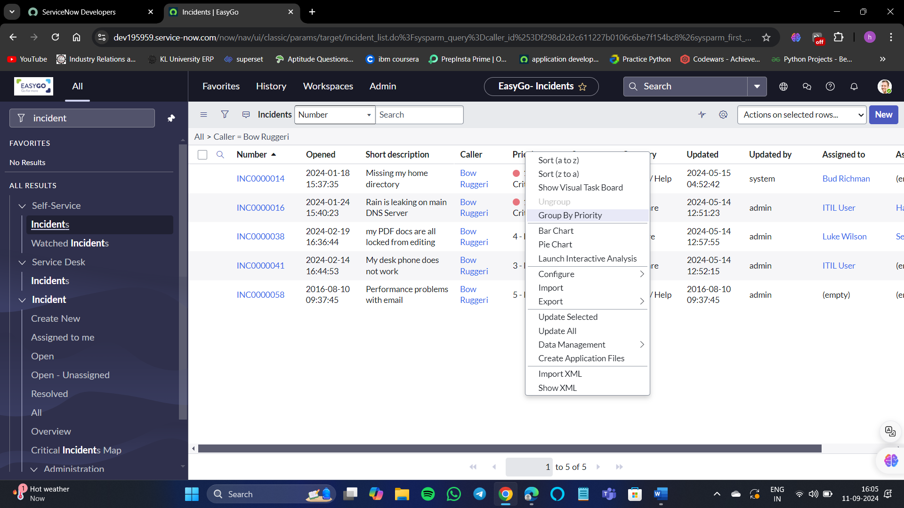

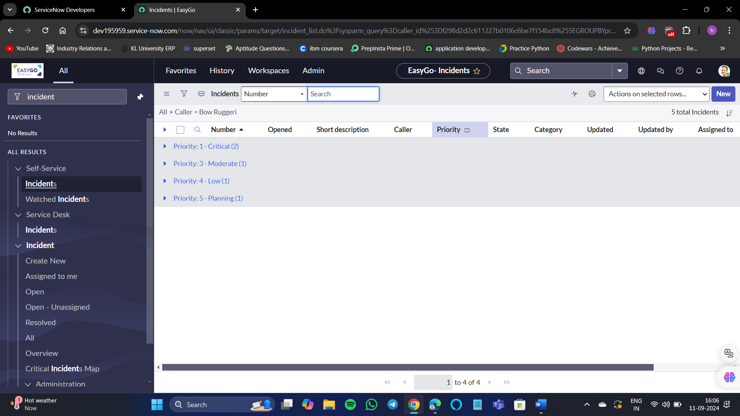

If you want to ungroup the priority column then again right-click on priority and ungroup the priority column.

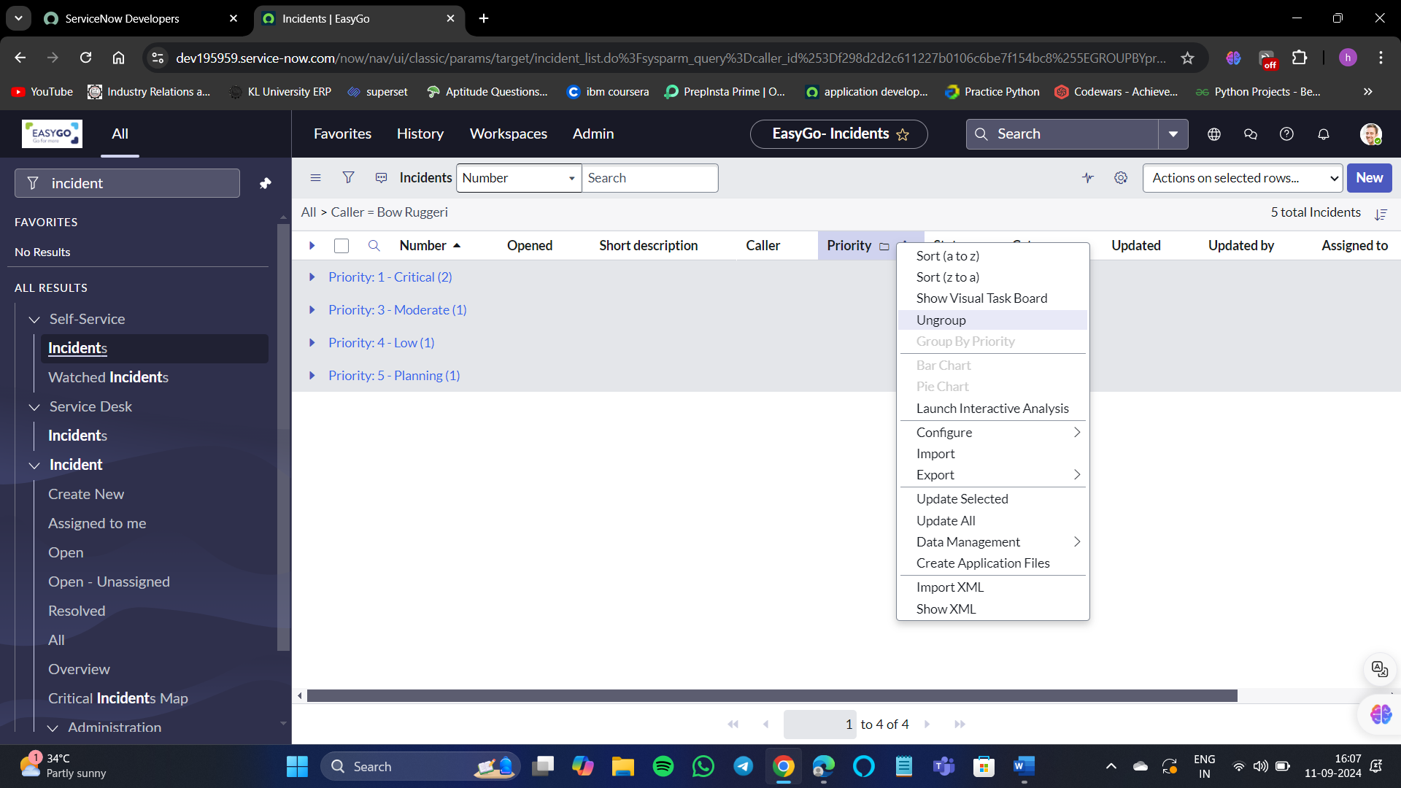

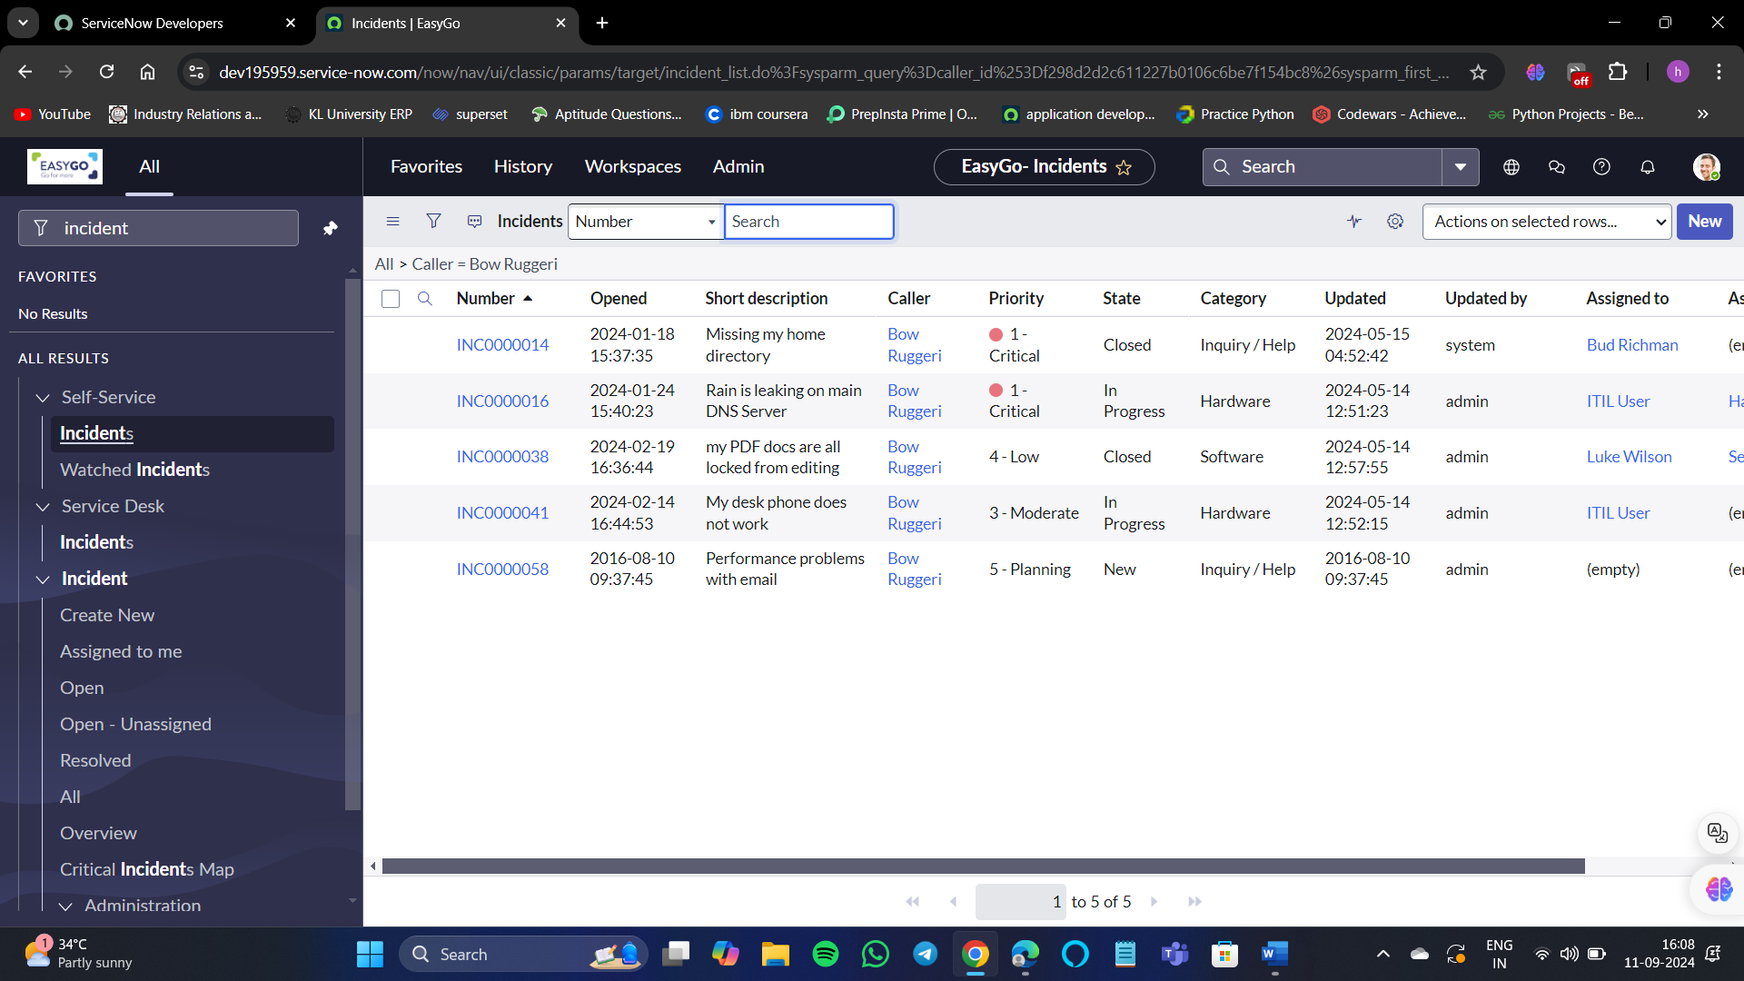

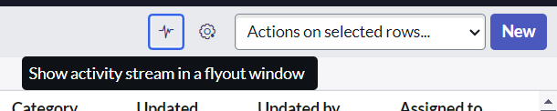

1. Activity Stream
2. Personalize gear

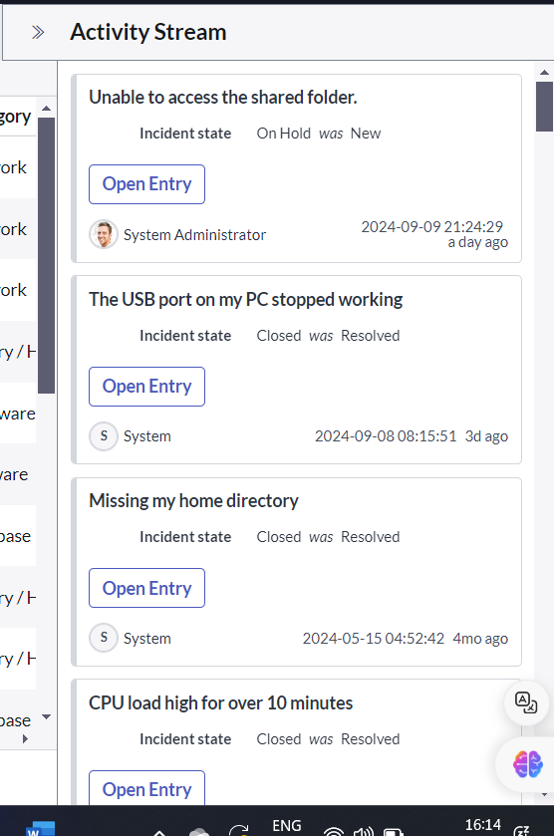

A feature that displays a list of entries related to records and conversations, such as comments, journal fields, and work notes. It provides users with context about associated records by showing activities that have occurred. Additionally, it enables agents to communicate with requesters and document their work on a record via internal notes.

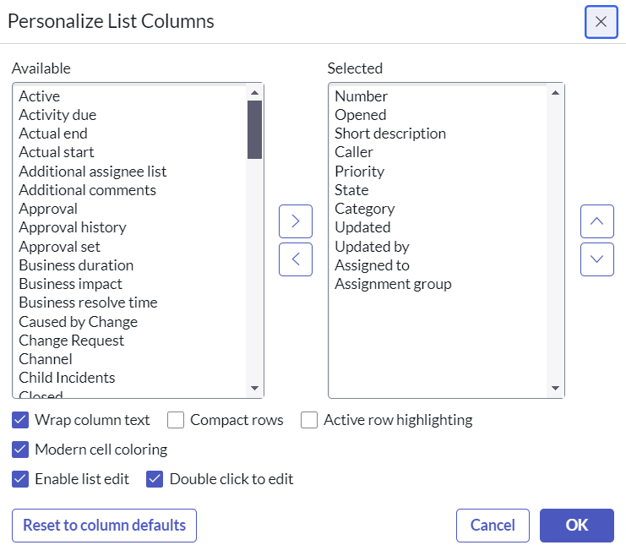

As we can see here there are 2 columns, available and selected.

We can adjust them by those arrows. For example, I don’t what is assigned to an assignment group. So, select them and < then okay.

For example, if I don’t want to be Assigned to and assignment group to be displayed in the table, then select those 2 and select the less than symbol(<).

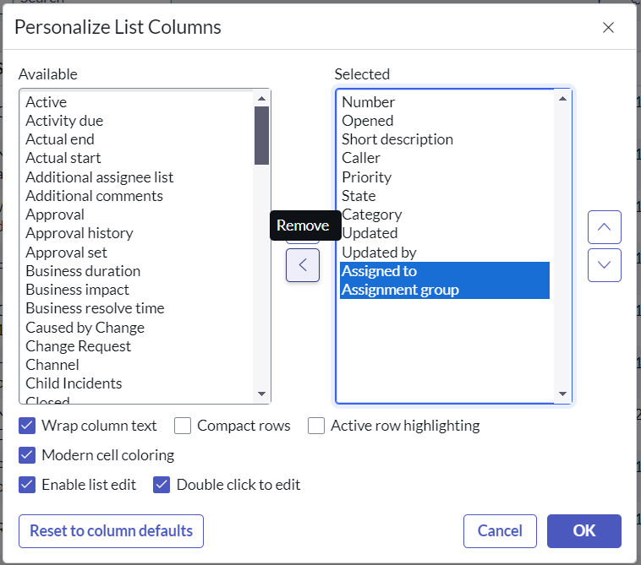

Select ok. Refresh the page for the change to reflect.

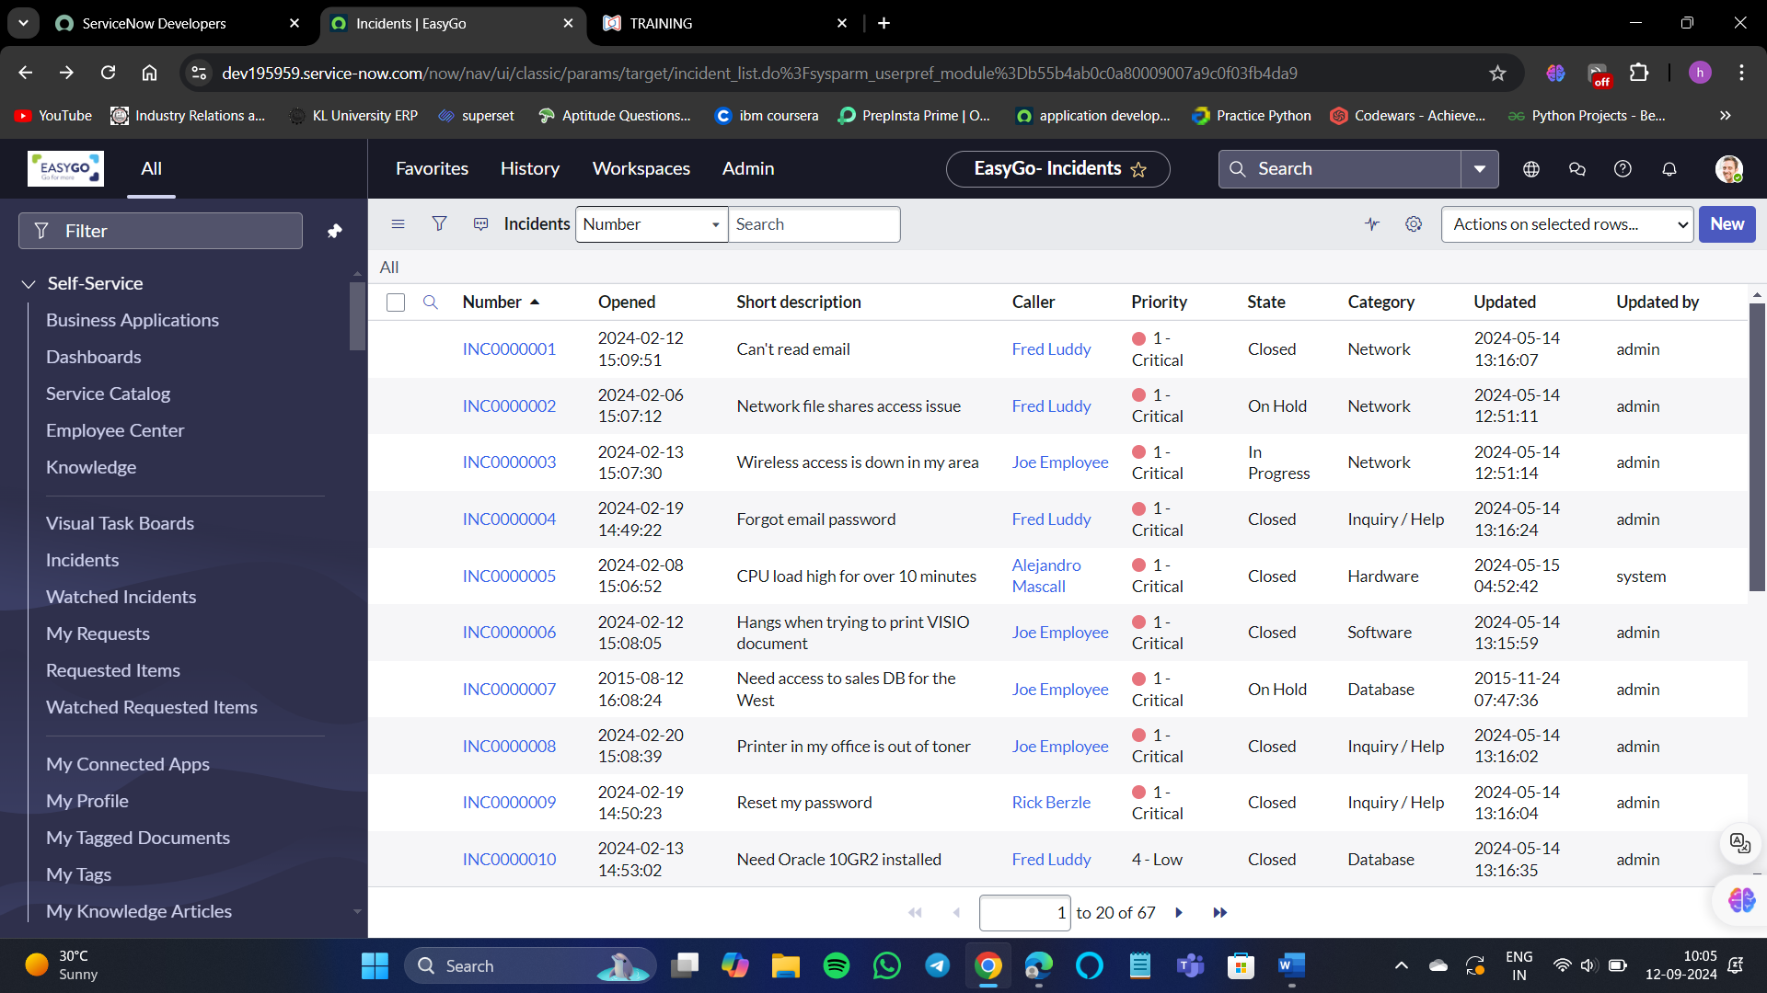

Those 2 columns are removed successfully.

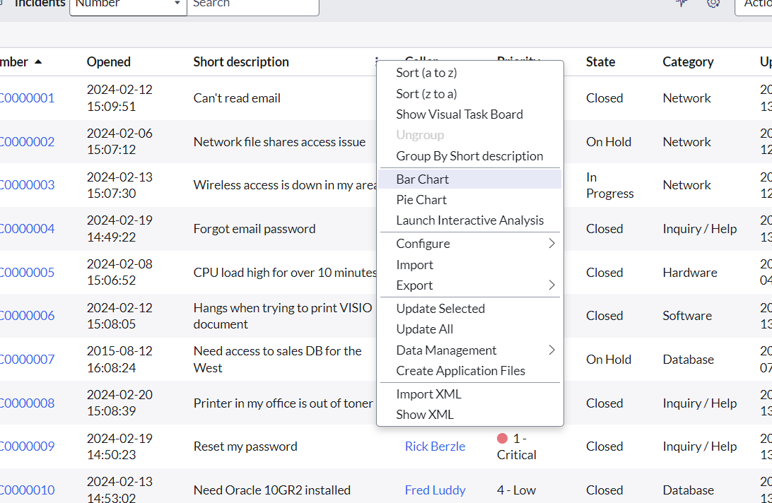

We can see options called as Bar chart, pie chart, etc.

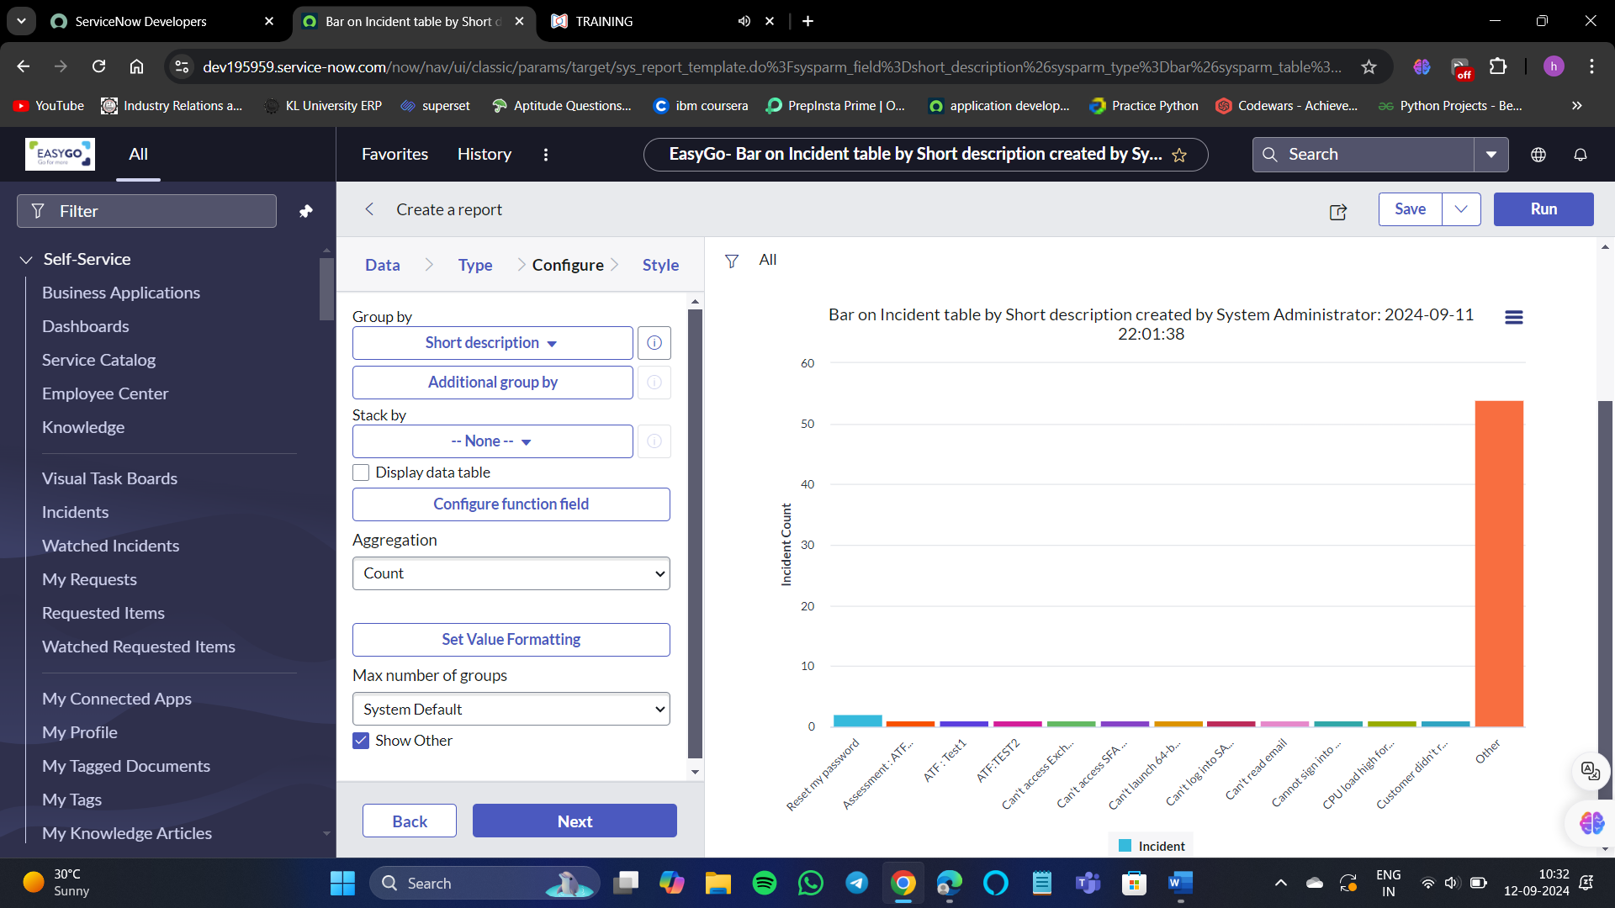

This is how you work on lists and filters.

**Forms:**

Forms are content pages that display fields and values for a single record from a database table. They serve as the user interface where agents perform most of their tasks, and they can be configured by administrators to customize what appears on the forms. Forms typically have various layout options, such as 1-column or 2-column arrangements.

**Topics to learn about forms:**

1. How forms show data from the table
2. Components of forms
3. Form personalization
4. Form customization
5. Form templates

Form displays information from one record in a data table.

For example, this record which is showing details of the problem record from the problem table users can edit and create specific records as per the access they have in the system.

**Form elements:**

1. Content frame: which is the main section where details of a record are displayed.
2. Form title: where you see the information about the record and buttons of the form.
3. Form menu: This shows some menu options to perform some functionalities and configure the form.
4. Form buttons: which are also called as UI actions which can be utilized to perform some action on the form.

Let’s explore more about forms.

Create a new record, the created record will be saved in the incident table of records.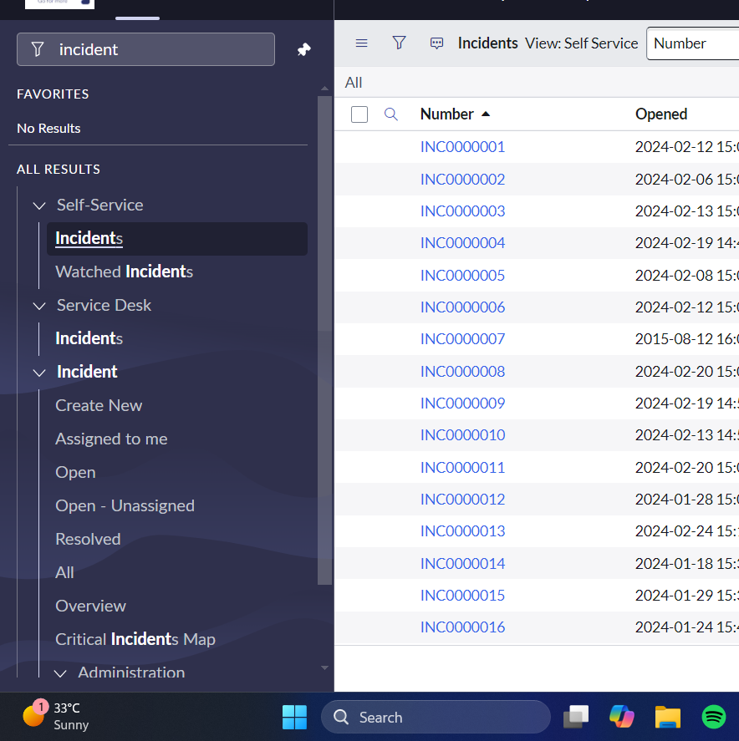

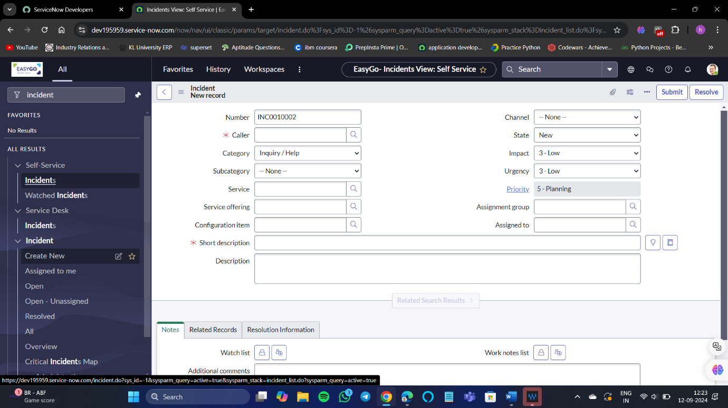

Enter the details.

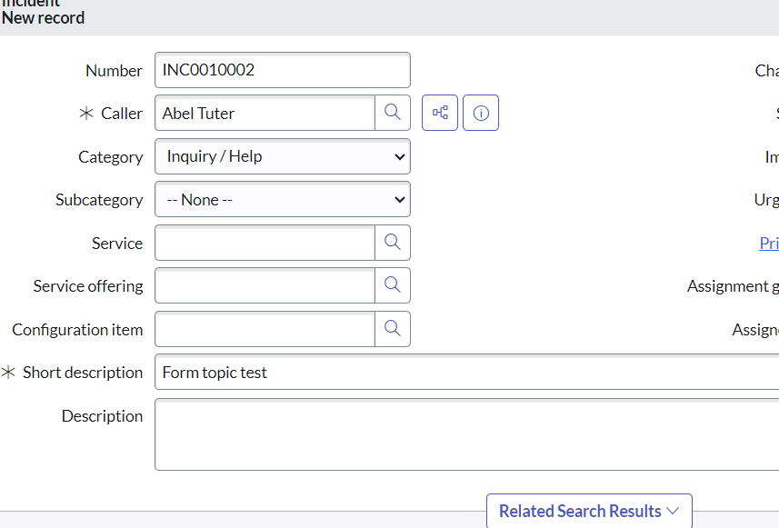

There are 2 options, one is save and other is submit.

So, now the difference between save and submit is:

1. Submit: When you submit the record then the form page will disappear and the incident table is with the newly created record will be displayed.

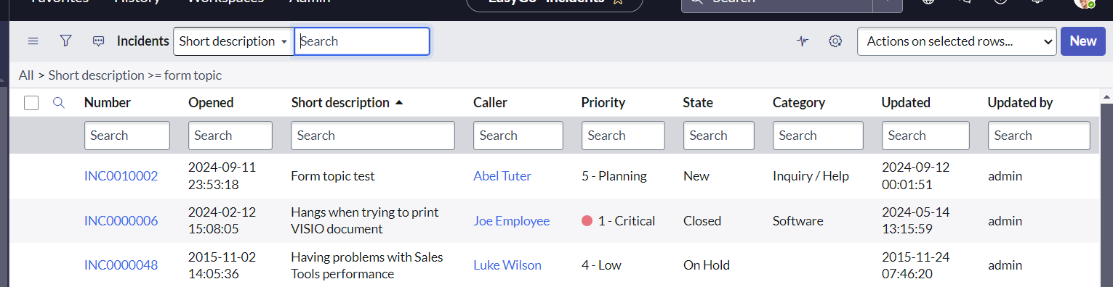

1. Save: Now open the created record and change the short description and save the record.

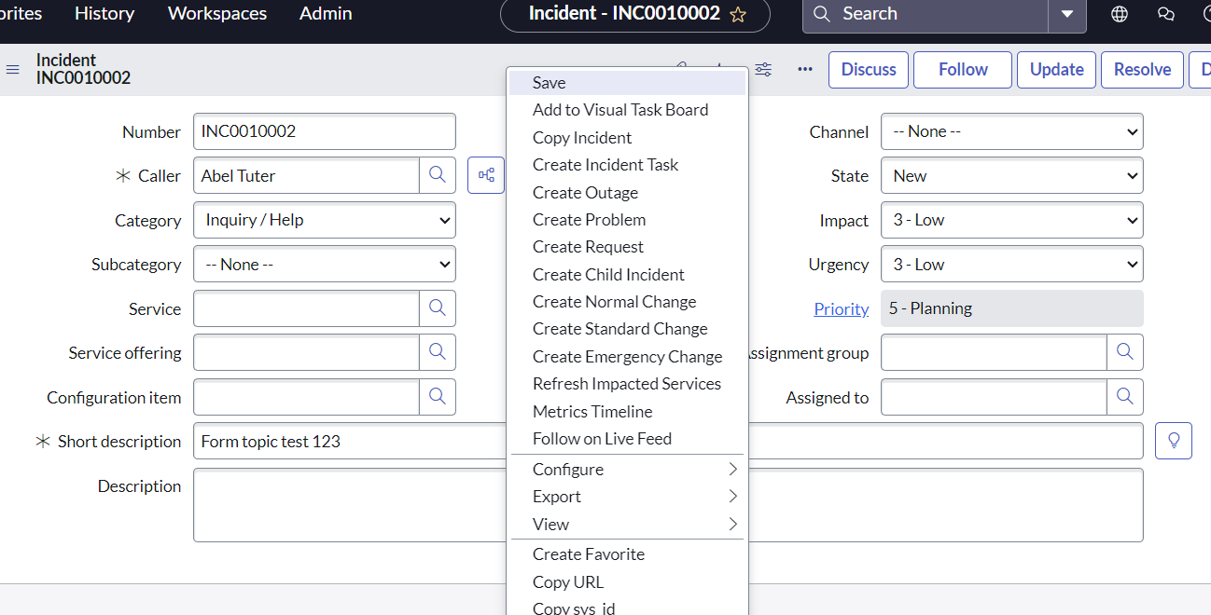

Now you can see the difference between submit and save.

If you submit the record, the form will disappear, and the record will be displayed in the incident table where all the records are displayed. If you save the record, then we can still see the form and make any changes if needed.

There are other 2 important components in forms:

1. Mandatory fields
2. Read-only fields

**Mandatory fields:** While creating a new record we can observe a red asterisk. Those are called mandatory fields. This means that you need to fill that area compulsorily.

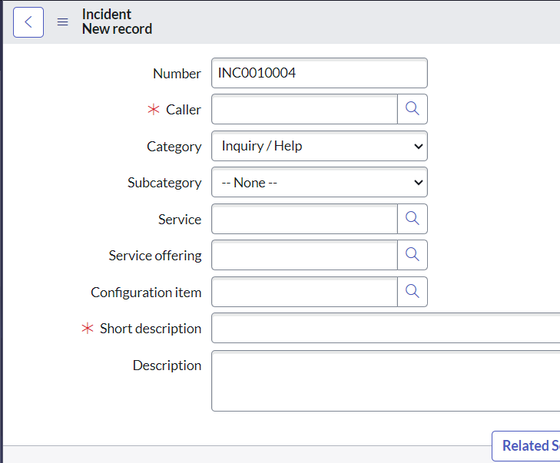

**Read-only field:** It is a field where users can only view it but cannot edit it. So, read-only fields are non-editable fields which cannot be edited by the user on the form.

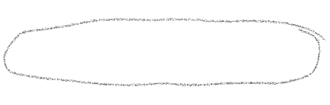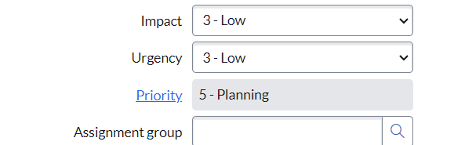

**Choice fields:** where users can select the value from the drop-down options.

**Reference fields:** these are the fields which shows the value stored in different table.

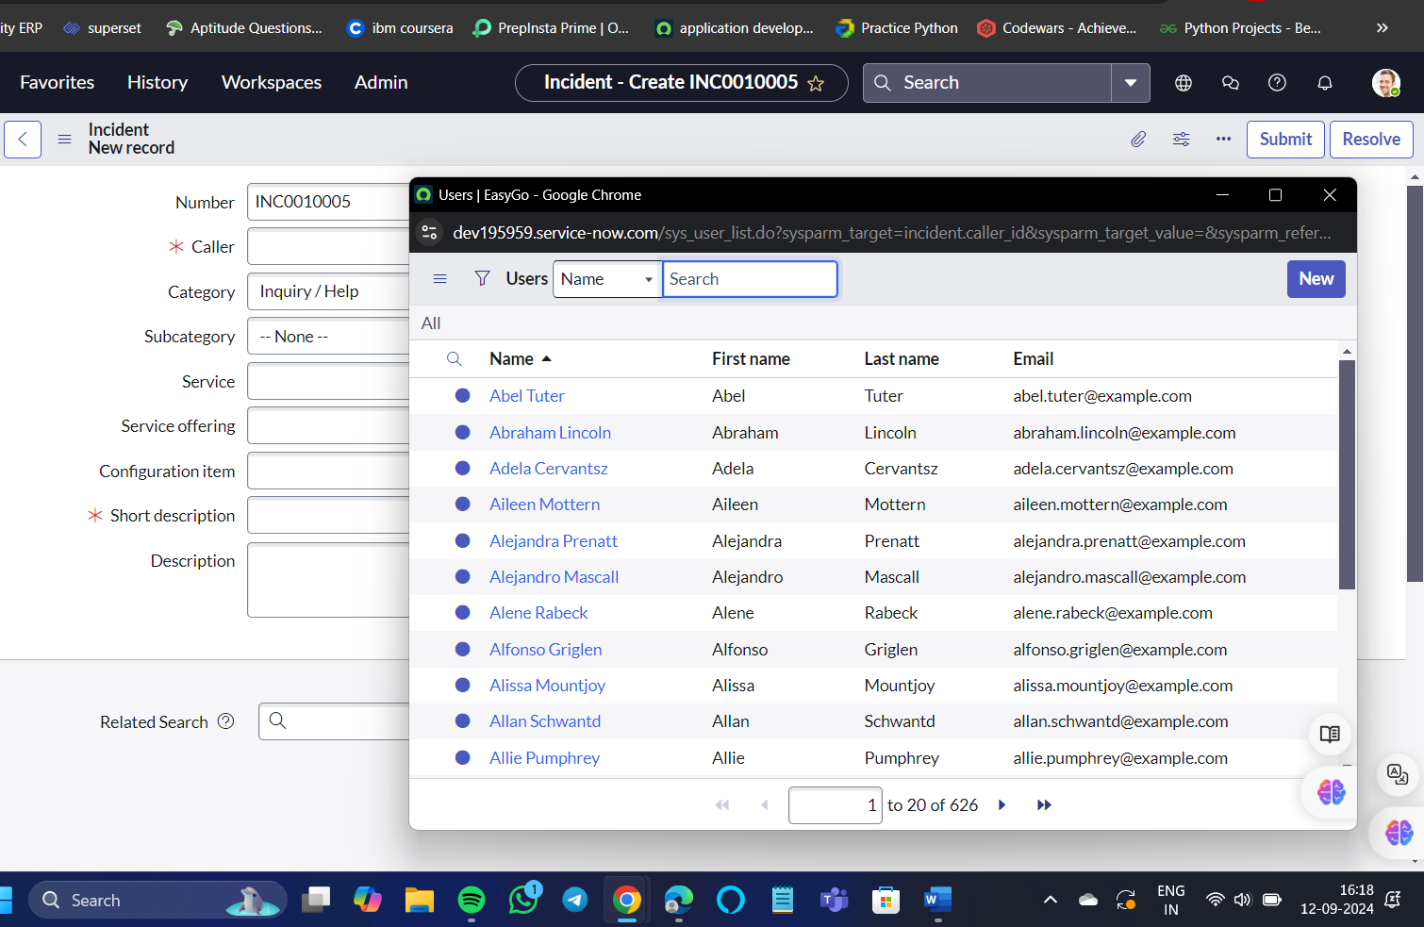

Here we select any user for the reference field – caller.

**Form configuration:**

The fields and layout of the form can be configured. ServiceNow admins can perform this configuration. Overall, you can change the form design with 2 different options,

1. Form layout: you can create new views and fields and adjust the form layout to be visible to the users.
2. Form design: this is an advanced way to create the field and adjust the design on the form. You can also select the views via form design as well. You can configure the form layout by right-clicking on the title bar of the form.

